**LVS + DR Load Balancing**

LVS + DR Load Balancing

**OS:** CentOS-6.10

Close Firewall command: service iptables stop

3 CentOS Virtual Machines in macOS:

Node1: LVS Balancer 172.16.6.181

Node2: httpd server 172.16.6.182

Node3: httpd server 172.16.6.183

**Connect Network Adapter Option:**

Share with my Mac (NAT option)

Node1: ifconfig eth0:2 172.16.6.188/24

Node2 && Node3:

Modify kernel:

echo 1 > /proc/sys/net/ipv4/conf/eth0/arp_ignore

echo 1 > /proc/sys/net/ipv4/conf/all/arp_ignore

echo 2 > /proc/sys/net/ipv4/conf/eth0/arp_announce

echo 2 > /proc/sys/net/ipv4/conf/all/arp_announce

Set up Hidden VIP:

ifconfig lo:3 172.16.6.188 netmask 255.255.255.255

**Node2 and Node3 Install httpd:**

yum install httpd –y

service httpd start

echo ‘From IP 172.16.6.182’ > /var/www/html/index.html (Node2)

echo ‘From IP 172.16.6.183’ > /var/www/html/index.html (Node3)

**Node1 Set up LVS:**

yum install ipvsadm

[root@centosa adrian]# ipvsadm -A -t 172.16.6.188:80 -s rr

[root@centosa adrian]# ipvsadm -a -t 172.16.6.188:80 -r 172.16.6.182 -g -w 1

[root@centosa adrian]# ipvsadm -a -t 172.16.6.188:80 -r 172.16.6.183 -g -w 1

[root@centosa adrian]# ipvsadm -ln

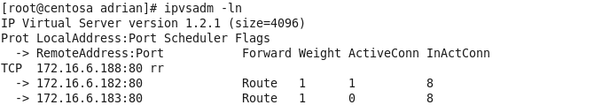

NodeB:

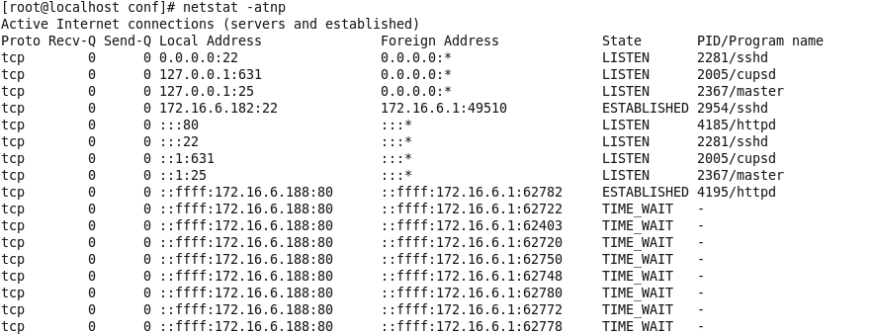

NodeC:

